

PROJECT TITLE – AGRICULTURAL PRODUCE MANAGEMENT SYSTEM

PROJECT PROPOSAL

PRESENTED BY :

NAME : ODHIAMBO JOHN OTIENO

REGISTRATION NUMBER : SCS3/147357/2023

Executive Summary

This is a produce tracking system designed to help farmers monitor and manage their produce from harvest to sale. The application aims to streamline produce management, providing real-time updates on inventory and sales, and offering valuable insights to improve efficiency and profitability. The scope includes 3 primary modules Produce, Sales & Reports.

This is an online platform. It allows farmers to manage update and monitor their agricultural business by accessing various services, and perform administrative tasks. Some functionalities provided by the system include produce management , sales tracking and the generation of various reports to allow farmers to keenly analyze and modernize their businesses in an efficient, professional and in a comprehensive manner no matter the scale of their operations. The system is designed to be accessed through a web-based platform that ensures secure access and centralized data storage. The platform is organized into modules which are accessed individually based on the users’ needs to provide ease of access.

Contents

1. Introduction 3

Background 3

Problem Statement 3

Objectives 3

Scope 3

Assumptions 3

2. System Overview 4

FLOW DIAGRAM 4

Flow of Events 7

Use Cases 9

# Introduction

## Background

Managing produce efficiently is a significant challenge for farmers, leading to potential losses and reduced profitability. The system addresses this need by providing a tracking system that helps farmers monitor production, inventory, and sales.

## Problem Statement

There are numerous instances of produce tracking systems, however, most of them are expensive to small scale farmers and complex to use hence small-scale farmers currently lack a simple and effective way to monitor and manage their produce from harvest to sale. This project aims to fill that gap by offering a user-friendly produce tracking system.

## Objectives

- Develop a web application with produce tracking capabilities.

- Ensure secure access to user accounts.

- Ensure farmers can access reports on their agricultural activity.

- Ensure farmers can monitor their sales activity.

-Ensure ease of access by implementing training tutorials.

## Scope

This will include three primary modules: Sales, Produce, and Reports, as well as additional modules Settings and Notifications on a web-based platform.

## Assumptions

Users have internet connectivity.

Users have a device to access the web.

# 2. System Overview

## FLOW DIAGRAM

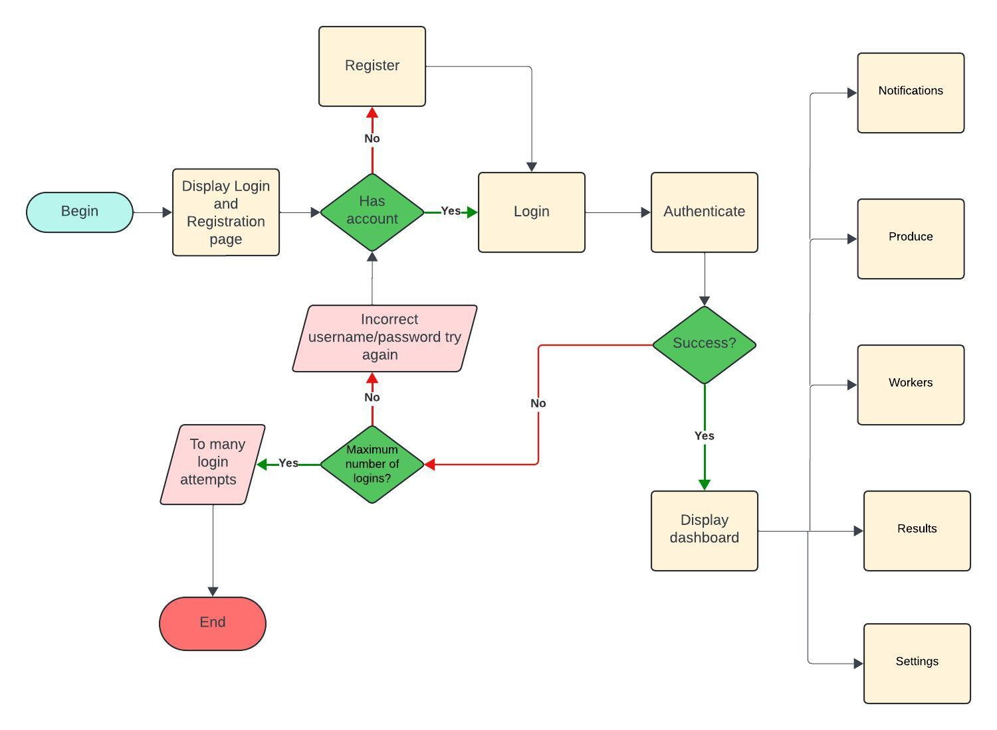

1. Settings

Submodules

1. Account management
2. Security
3. Help
4. Account management

* Name
* Email
* Phone / telephone
* Country
* County
* Delete account

1. Security

* Change Password
* Enable 2FA

1. Help

* About us – Display about page
* Contact Support – Display email and telephone number
* Training tutorials – Display tutorial videos to common tasks.

1. Notifications Module

Modes of notification – email, SMS

Notify me when:

* + A sale is made
  + Harvesting season reminder
  + Low Inventory
  + Crops near spoil
  + Scheduled sale date
  + Reminders to make payments

1. Produce Module
   * Dashboard Overview: A quick summary of current produce status, including

* + - total inventory
    - recent harvest
* Produce Entry: Form to input new produce details such as
* type,
* quantity,
* harvest date,
* storage location.
* Expected sale date
* Type grain , fruit / vegetable , tubers
* Inventory Management: Tools to
* track harvested produce.
* Assign storage spaces.
* monitor storage conditions
* receive alerts for low stock / approaching expiration.
* Planting Management: Calendar or timeline view to manage notifications on planting , weeding and crop care such as fumigation.

1. Sales Module

Record sales transactions, including

* + buyer details,
  + quantity sold,
  + sale price
  + date of sale.

1. Reports Module

- Generate Reports: Create various reports, such as inventory status, sales reports, production analysis.

- Customizable Filters: Allow users to customize reports with filters, such as date range, specific produce items.

- Data Visualization: Use charts, graphs, and tables to present report data in an easily understandable format.

## Flow of Events

1. User Registration and Authentication

- Event: Farmers register on the APMS platform.

- Details: Farmers provide their basic information and create an account. Optional 2FA authentication can be set up.

- Outcome: A secure account is created for the farmer, enabling personalized access.

2. Login and Dashboard Overview

- Event: Farmer’s log into their APMS accounts.

- Details: Farmers enter their credentials to access the system.

- Outcome: Farmers are presented with a dashboard overview, including produce status, weather forecast, and recent sales activities. Visual representations like charts and graphs are used for easy understanding.

3. Produce Entry

- Event: Farmers enter details of newly harvested produce.

- Details: Farmers input information such as type of produce, quantity, harvest date, and expected sale date.

- Outcome: Produce data is stored in the database, and inventory levels are updated.

4. Inventory Management

- Event: Farmers monitor and manage their inventory.

- Details: Farmers can view real-time inventory levels, update quantities, track storage conditions, and receive alerts for low inventory or nearing expiration.

- Outcome: Efficient inventory management ensures produce is utilized or sold before spoilage, reducing waste.

5. Sales Tracking

- Event: Farmers record sales transactions.

- Details: Farmers input sales details, including buyer information, quantity sold, sale price, and date of sale.

- Outcome: Sales records are updated, and farmers can monitor sales trends and performance over time.

6. Reports and Insights Generation

- Event: Farmers generate reports to analyze their operations.

- Details: Farmers can create various reports, such as inventory status, sales performance, and historical data analysis.

- Outcome: Insights and recommendations help farmers make informed decisions to improve productivity and profitability.

7. Notifications and Alerts

- Event: System sends alerts and notifications to farmers.

- Details: Farmers receive push notifications or alerts for important updates, such as low inventory levels, produce nearing expiration, or upcoming sales deadlines.

- Outcome: Timely alerts ensure that farmers take necessary actions to manage their produce efficiently.

8. Support and Training

- Event: Farmers access support and training resources.

- Details: In-app help, tutorials, and customer support are available to assist farmers in using the system effectively.

- Outcome: Farmers are equipped with the knowledge and support needed to maximize the benefits of APMS.

By following this flow of events, APMS helps farmers efficiently manage their produce, from harvest to sale, enhancing their overall productivity and profitability

## Use Cases

1. Harvest Management

- Scenario: A farmer has just completed harvesting their crop of tomatoes.

- Action: The farmer logs into APMS and enters details about the harvested tomatoes, including the quantity, harvest date, and storage location.

- Benefit: This helps the farmer keep track of the harvested produce and ensures that all inventory data is up to date.

2. Inventory Monitoring

- Scenario: A farmer needs to monitor the inventory levels of their stored produce.

- Action: The farmer uses APMS to view real-time inventory levels and receive alerts when the inventory is low or produce is nearing its expiration date.

- Benefit: The farmer can take timely action to sell or use the produce before it spoils, reducing waste and maximizing profits.

3. Sales Tracking

- Scenario: A farmer sells a batch of oranges to a local grocery store.

- Action: The farmer records the sale in APMS, including details such as the buyer, quantity sold, sale price, and date of sale.

- Benefit: This allows the farmer to maintain accurate sales records and analyze sales trends over time to identify the most profitable produce and sales periods.

4. Production Analysis

- Scenario: A farmer wants to analyze the performance of different crops over the past year.

- Action: The farmer generates reports in APMS to review historical data on production, inventory levels, and sales performance.

- Benefit: This provides valuable insights into which crops are performing well and helps the farmer make informed decisions about future planting and resource allocation.

5. Market Planning

- Scenario: A farmer plans to enter a new market and needs to estimate the potential supply and demand.

- Action: The farmer uses APMS to analyze inventory data and forecast production levels based on historical trends.

- Benefit: This helps the farmer plan their market entry strategy and ensure they have enough produce to meet demand.

6. Quality Control

- Scenario: A farmer wants to ensure the quality of their produce is maintained during storage.

- Action: The farmer uses APMS to track storage conditions and receive alerts for any deviations that could affect produce quality.

- Benefit: This ensures that the produce remains in optimal condition, leading to higher quality and better market prices.

7. Compliance and Traceability

- Scenario: A farmer needs to provide traceability information for their produce to meet regulatory requirements.

- Action: The farmer uses APMS to generate traceability reports that track the produce from harvest to sale.

- Benefit: This helps the farmer comply with regulations and provides transparency to buyers, enhancing trust and marketability.

DATABASE DESIGN

1. User Accounts Table:

- `UserID` (Primary Key)

- `UserName`

- `Password`

- `Email`

- `Phone`

- `Role` (e.g., Farmer, Admin)

2. Farms Table:

- `FarmID` (Primary Key)

- `UserID` (Foreign Key)

- `FarmName`

- Country

- Region

- `FarmSize`

- `CropType`

3. Produce Table:

- `ProduceID` (Primary Key)

- `FarmID` (Foreign Key)

- `ProduceType`

- `Quantity`

- `HarvestDate`

4. Sales Table:

- `SaleID` (Primary Key)

- `ProduceID` (Foreign Key)

- `SaleDate`

- `QuantitySold`

- `SalePrice`

5. Reports Table:

- `ReportID` (Primary Key)

- `UserID` (Foreign Key)

- `ReportType`

- `GeneratedDate`

Relations

- Each user can have one farm .

- Each farm can have multiple produce entries.

- Each produce entry can have multiple sales records.

- Each user can generate multiple reports.

How to Enhance User Experience using the database.

1. Personalized Dashboards:

- Show tailored data like farm produce status, sales reports, etc., based on User ID.

2. Data Security:

- Ensure data privacy using encryption for sensitive information such as passwords.

3. Automated Reports:

- Generate reports on user activities and farm data. Admins should access overall platform health and analytics.